Profile

1 | NameoftheFaculty | HANAMANTH RAO |  |  | 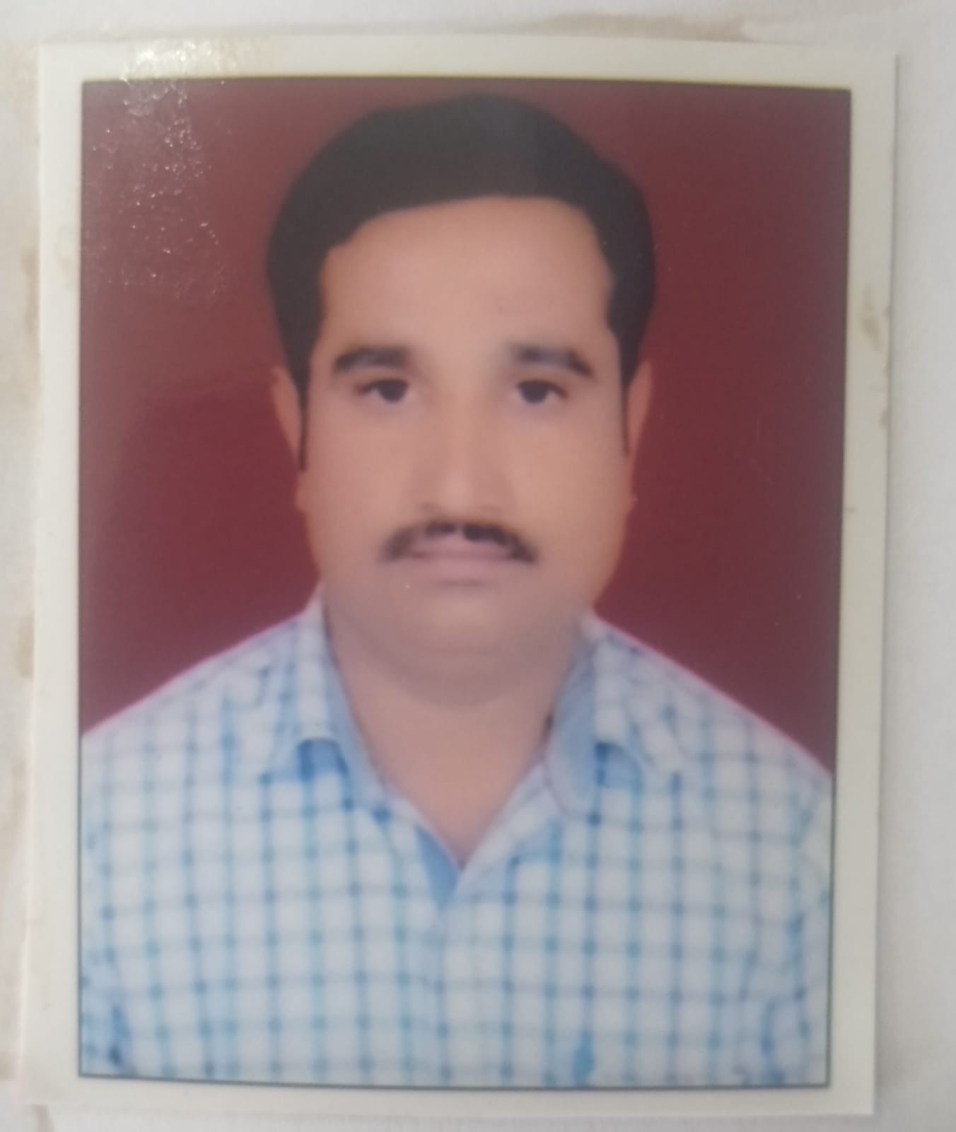  pht
2 | Dateofjoining | 08/05/2008
3 | Email id | hsbiradar@gmail.com
4 | Designation | ASSISTANT LIBRARIAN
5 | Department | Library & Information Center
6 | EducationQualifications | B.L.I.Sc & M.L.i sc
7 | WorkExperience | Librarian | Assistant Librarian |  | Library Assistant | Others
 |  |  | 13 years |  | 2 years
8 | AreaofSpecialization
9 | Courses taught at Diploma/ PostDiploma/ Under Graduate/ PostGraduate/PostGraduateDiploma  Level
10 | No.ofpaperspublishedinNational/InternationalJournals/Conferences
 | Journals Published | National |  | International
 |  | 1
 | Conferences attended | National |  | International
 |  | 4 |  | 1
 | ResearchGuidance
 | MasterDegree | Completed |  | Ongoing
 |  | 2010
 | Ph.D.

11 | ProjectsCarriedout
12 | Patents
13 | TechnologyTransfer
14 | Publications in International/ National Journals  1)xya name, basavaraj amarapur, “active contour model applied to segmentation of human face”, in innovations in electronics and communication engineering, lecture notesin Networks and Systems 33, pp- 31-36, Springer,https://doi.org/10.1007/978-981-10-8204-7_42. (Scopus Indexed).  2)

